**Week 6 Written Assignment**

Ayomide Stephen Oyedele

EC-Council University

**CIS 300: Fundamentals of Information Systems Security**

Dr. Franklin Orellana

February 18, 2024

In today's rapidly evolving cybersecurity landscape, organizations face increasingly sophisticated threats that target their network infrastructure, making it imperative to adopt strategic technologies to enhance network security. One such technology is Security Awareness Training, which empowers users to recognize and respond effectively to potential security threats. By educating employees about cybersecurity best practices, such as identifying phishing attempts and creating strong passwords, organizations can build a human firewall that acts as the first line of defense against cyberattacks. Security Awareness Training instills a culture of vigilance among users, equipping them with the knowledge and skills needed to safeguard sensitive information and mitigate the risk of human error leading to security breaches.

Segmentation of the Local Area Network (LAN) into Virtual LANs (VLANs) is another strategic technology that organizations can leverage to bolster network security. VLAN segmentation enables organizations to create distinct network segments for different departments or user groups, effectively isolating network traffic and limiting the impact of potential security breaches. By separating sensitive data from less critical assets, VLANs help organizations enforce stricter access controls and minimize the lateral movement of attackers within the network. Additionally, VLANs facilitate the implementation of granular security policies, allowing organizations to tailor security measures to the specific needs and risk profiles of each network segment.

At the boundary between the LAN and the Wide Area Network (WAN), organizations can deploy Unified Threat Management (UTM) devices to fortify their network defenses. UTM devices offer a comprehensive suite of security features, including firewall, intrusion detection and prevention, antivirus, and content filtering capabilities, all integrated into a single appliance. By consolidating multiple security functions into a unified platform, UTM devices provide organizations with a cost-effective and streamlined approach to network security. With proactive threat detection and mitigation capabilities, UTM devices enable organizations to detect and respond to cyber threats in real time, minimizing the risk of successful attacks and safeguarding the integrity and confidentiality of their data assets.  
  
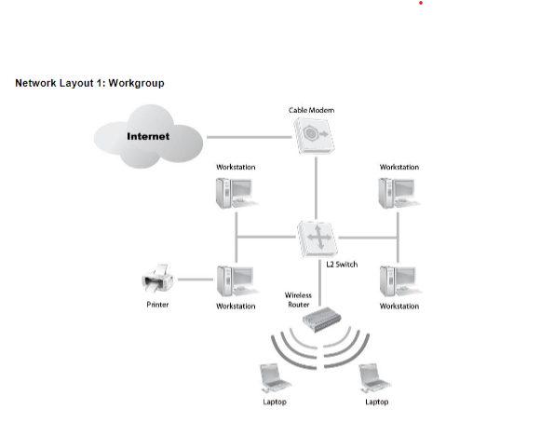:

1. **User Domain:**

* Strategy: Implement Security Awareness Training

Justification: Educating users about security best practices, such as identifying phishing attempts, creating strong passwords, and recognizing suspicious activities, can significantly reduce the risk of human error leading to security breaches. By providing regular security awareness training sessions, users become more vigilant and proactive in safeguarding sensitive information.

2. **LAN Domain:**

* Strategy: Segment the LAN into Virtual LANs (VLANs)

Justification: VLAN segmentation enhances network security by isolating network traffic between different departments or user groups. By creating separate VLANs for finance, HR, and IT departments, for example, organizations can restrict access to sensitive data and limit the scope of potential security breaches. Additionally, VLANs allow for easier implementation of access control lists (ACLs) and intrusion detection systems (IDS) to monitor and manage network traffic more effectively.

3. **LAN-to-WAN Domain:**

* Strategy: Implement Unified Threat Management (UTM) Devices

Justification: UTM devices offer comprehensive security features, including firewall, intrusion detection and prevention, antivirus, and content filtering capabilities, all in a single integrated appliance. By deploying UTM devices at the perimeter of the network, organizations can effectively protect against a wide range of cyber threats originating from the internet. These devices provide proactive threat detection and mitigation, reducing the likelihood of successful attacks and enhancing overall network security posture.

By implementing these strategies across the user, LAN, and LAN-to-WAN domains, organizations can significantly enhance the security of their network infrastructure, reduce the risk of security breaches, and better protect sensitive data from unauthorized access or malicious activities.